Attachment 5 – Bond Adequacy Reporting Format

Sample Bond Reporting Format
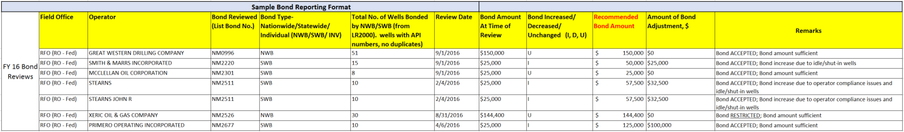

Prior FY Bond Increases In-Place (Example Only)
(Offices to focus on securing proposed bond increases)

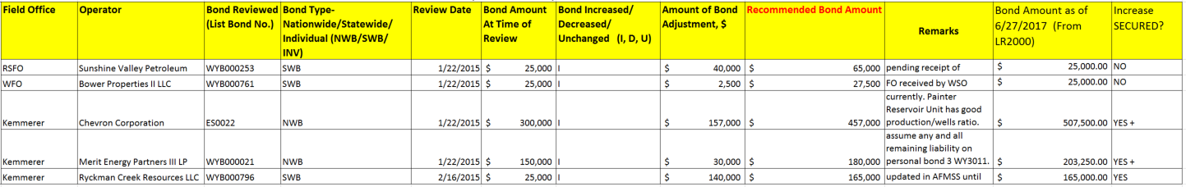

Summary Format
