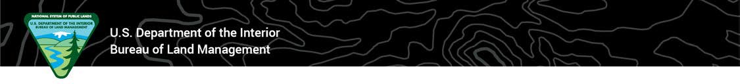
TEMPORARY CLOSURE ORDER
Bureau of Land Management, Nevada

CLOSURE OF Certain Lands

Within and outside the Moriah Herd Area

Action: Pursuant to 43 CFR 8364.1, the Bureau of Land Management (BLM) provides notice that, effective upon execution of this order, all public lands within a five-mile radius of any wild horse drive trap location and holding facility within and outside the Moriah HA Gather Area are closed to public entry.

The purpose of this closure is to protect public health and safety while supporting safe and efficient wild horse gather operations to ensure humane care and treatment of all animals captured. Only essential gather personnel will be allowed at trap and holding sites during operations, as well as any public observers who are properly escorted by BLM personnel in accordance with BLM’s gather observation policies.

This action is associated with the removal of excess wild horses as part of the Ely District’s Moriah Herd Area Wild Horse Drive Trap Gather. Additional information and updates regarding this gather operation is available at:

https://www.blm.gov/programs/wild-horse-and-burro/herd-management/gathers-and-removals/nevada-ely-do/2026-moriah-herd

Affected Area: This temporary closure includes all public lands within a 5-mile radius surrounding any wild horse trap locations and holding facilities within and outside the Moriah HA while gather operations are conducted as shown on the associated map.

Prohibitions: All forms of public access and entry are prohibited.

Penalties: Any person who violates this Order may be tried before a United States Magistrate and fined in accordance with 18 USC 3571, imprisoned no more than 12 months, or both, in accordance with 43 CFR 8364.1(e).

Effective: This Order is effective upon execution of the Decision Record and will remain in effect through completion of gather operations (approximately July 20-August 5, 2026) within and outside the Moriah HA or until the BLM rescinds the order, whichever occurs sooner.

Executed by:

Melanie A. Peterson Date
Field Manager, Bristlecone Field Office