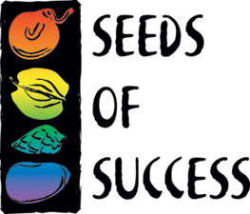Seeds of Success Annual Report

Organization (Agency, Field office, or org name): | Team Code:
Location (where did you collect?):

Number of species collected: | Number of SOS collections made:
Number of people on collection team: | Names/roles of people on collection team:
Collecting Season Summary (including accomplishments, challenges, missing data, renumbered collections, notes on private lands access, anything that someone in the future should know about the season and these collections):

Partners (Other agencies, NRCS, non-profit, etc.) and in what capacity you worked together:

Organizations that provided volunteers, and how many:

Education and Outreach (include any work with other groups to promote or highlight Seeds of Success, i.e., citation for a newsletter, web article, conference/meeting display, or presentation on SOS and/or the Native Plant Materials Development Program, etc.):

Format  (talk, exhibit, publication) | Title | Name of Event or Publication | Location  (Nearest City, State) | Date

SOS Collections (include information for collections that have been shipped out of your office to any seed cleaning facility for inclusion in the SOS program):

Species | SOS Seed Coll. Ref. Num  (e.g., NV030-xx) | Receiving Institution  (e.g., Bend Seed Extractory) | What the SOS Material will be Used For  (e.g., restoration, research) | Notes

Internal use, non-SOS collections (include tracking information for collections that are kept at your office for Native Plant Materials Development projects. This section is for non-SOS collections only):

Species | Seed Coll. Ref. Num  (e.g., CBFO-23-2020) | What the non-SOS material will be used for | Notes

Please submit the final annual report to your Agency Coordinator one week before the crew leaves, no later than December 15th.

BLM: Liz Enoch, eenoch@blm.gov
NPS: Katie Vinzant, Katharine_Vinzant@nps.gov AND Jonathan_Chase@nps.gov
USFWS: Kelly Thomas, kelly_thomas@fws.gov

