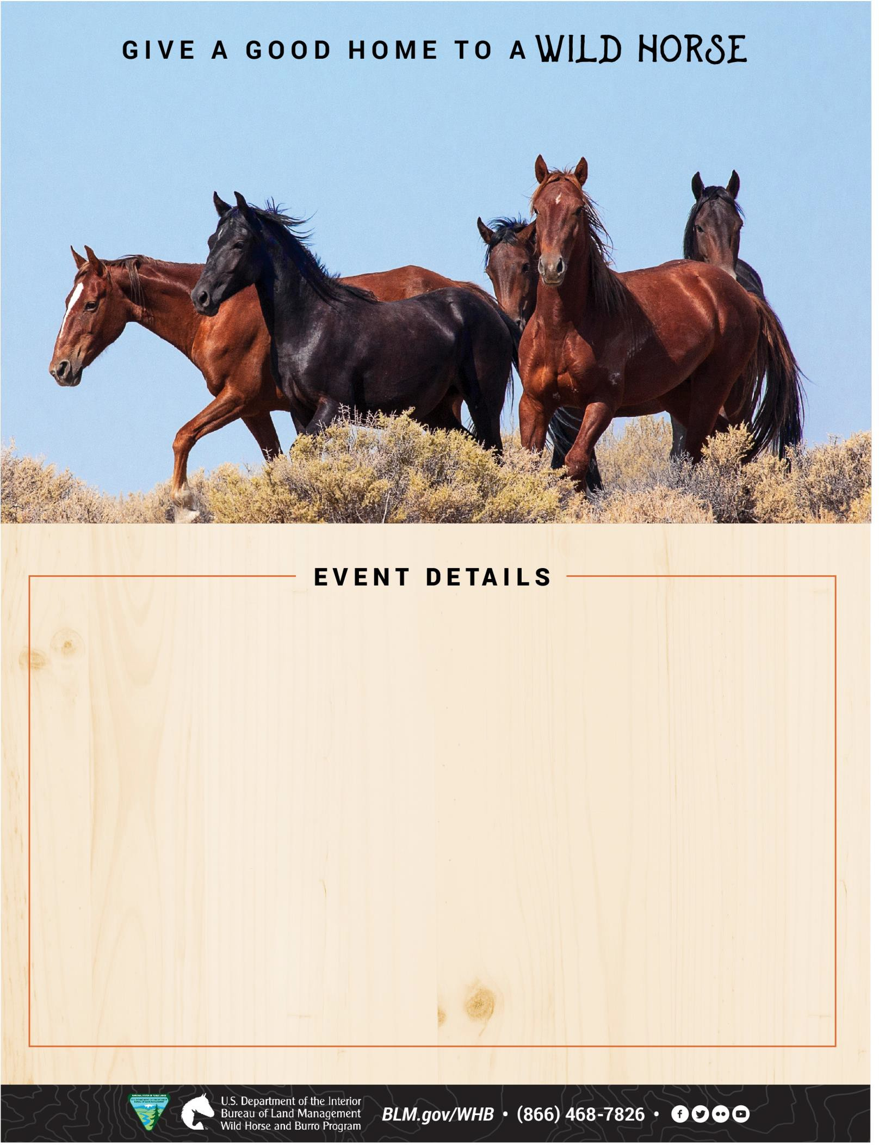

ELKHART, IA August 8 – 9, 2025

# APPOINTMENT PREFERRED

Prairie Rose Arena

11045 NE 56th Street

Elkhart, IA 50073

$125 minimum fee for animals adopted

$25 minimum fee for animals purchased

## Friday, August 8, 2025

Appointments from: 8 a.m. – 5 p.m. CDT

## Saturday, August 9, 2025

Appointments from: 8 a.m. – 1 p.m. CDT

Email appointment request:

[BLM_ES_NSDO_WHB@blm.gov](mailto:BLM_ES_NSDO_WHB@blm.gov)

One-hour increments for both days (five appointments per hour)

Please indicate your TOP 3 preferred time slots prior to event.

Come and adopt a horse or learn more about the program.