CARTHAGE, MO

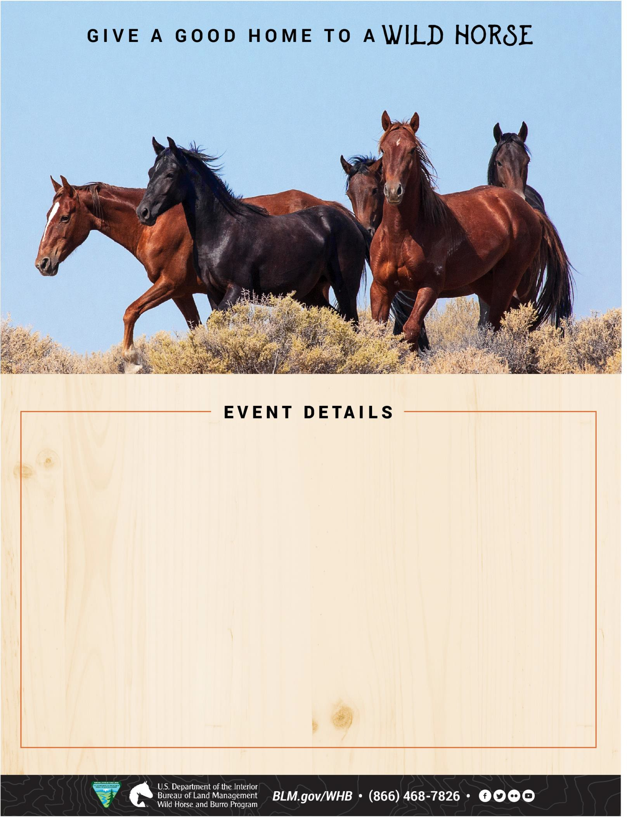

November 7 - 9, 2025

# APPOINTMENT PREFERRED

Civil War Arena

11838 Civil War Road

Carthage, MO 64836

$125 **minimum** **fee for** **animals adopted**

$25 **minimum** **fee for animals purchased**

## Thursday, November 7, 2025

OLC Pick-Ups from: 8 a.m. – 5 p.m. CDT

## Friday, November 8, 2025

Appointments from: 8 a.m. – 5 p.m. CDT

## Saturday, November 9, 2025

Appointments from: 8 a.m. – 1 p.m. CDT

Email Appointment Request:

[BLM_ES_NSDO_WHB@blm.gov](mailto:BLM_ES_NSDO_WHB@blm.gov)

One-hour increments for both days (five appointments per hour)

Please indicate your TOP 3 preferred time slots prior to event.

Come and adopt a horse or learn more about the program.