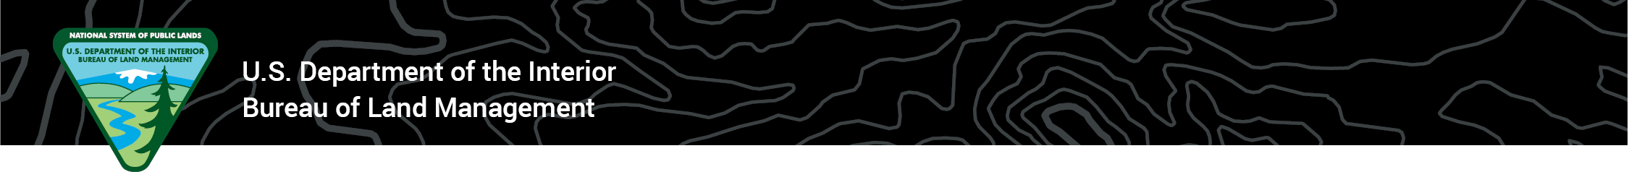**News Release  
Rocky Mountain District Office, Colorado**

For Immediate Release: TBD  
Contact: Levi Spellman, Public Affairs Specialist, (719) 839-1584

**Colorado’s Rocky Mountain Resource Advisory Council to Meet in November**

**CANON CITY, Colo**. – The Bureau of Land Management’s Rocky Mountain Resource Advisory Council (RAC) will meet at the BLM’s Royal Gorge Field Office on Nov. 9, 2023, from 9 a.m. to 11:45 a.m. MST. The meeting is open to the public. For those who prefer to attend virtually, please pre-register using this link: <https://blm.zoomgov.com/meeting/register/vJItcuiurT8rEyvXT4KovIWNrrPGWfrFf_g>

Agenda and registration information will be posted to the RAC’s webpage 30 days in advance, located at <https://www.blm.gov/get-involved/resource-advisory-council/near-you/colorado/rocky-mountain-rac>.

“Rocky Mountain RAC members represent Colorado’s communities east of the continental divide. Providing essential feedback on matters of public interest, RAC members are vital to successfully engaging those we serve. This process ensures broad perspectives are considered when decisions are made,” said **Rocky Mountain District Manager Cathy Cook.**

A public comment period is scheduled at 11:05 a.m. on Nov. 9. Agenda items include selecting a chairperson to lead the RAC and a vote on a fee proposal for recreation sites managed by the Royal Gorge Field Office.  
  
The three 15-member Resource Advisory Councils in Colorado are forums for providing advice and recommendations to the BLM on various resource and land management issues. The Rocky Mountain RAC advises the BLM Colorado Rocky Mountain District, including the Royal Gorge and San Luis Valley field offices, and Browns Canyon National Monument.

For more information, please contact Levi Spellman at the Rocky Mountain District public affairs office, (719) 839-1584 or [lspellman@blm.gov](mailto:lspellman@blm.gov).

-BLM-

*The BLM manages more than 245 million acres of public land located primarily in 12 western states, including Alaska, on behalf of the American people. The BLM also administers 700 million acres of sub-surface mineral estate throughout the nation. Our mission is to sustain the health, diversity, and productivity of America’s public lands for the use and enjoyment of present and future generations.*