

**Browns Canyon**

**National Monument**



**Colorado**

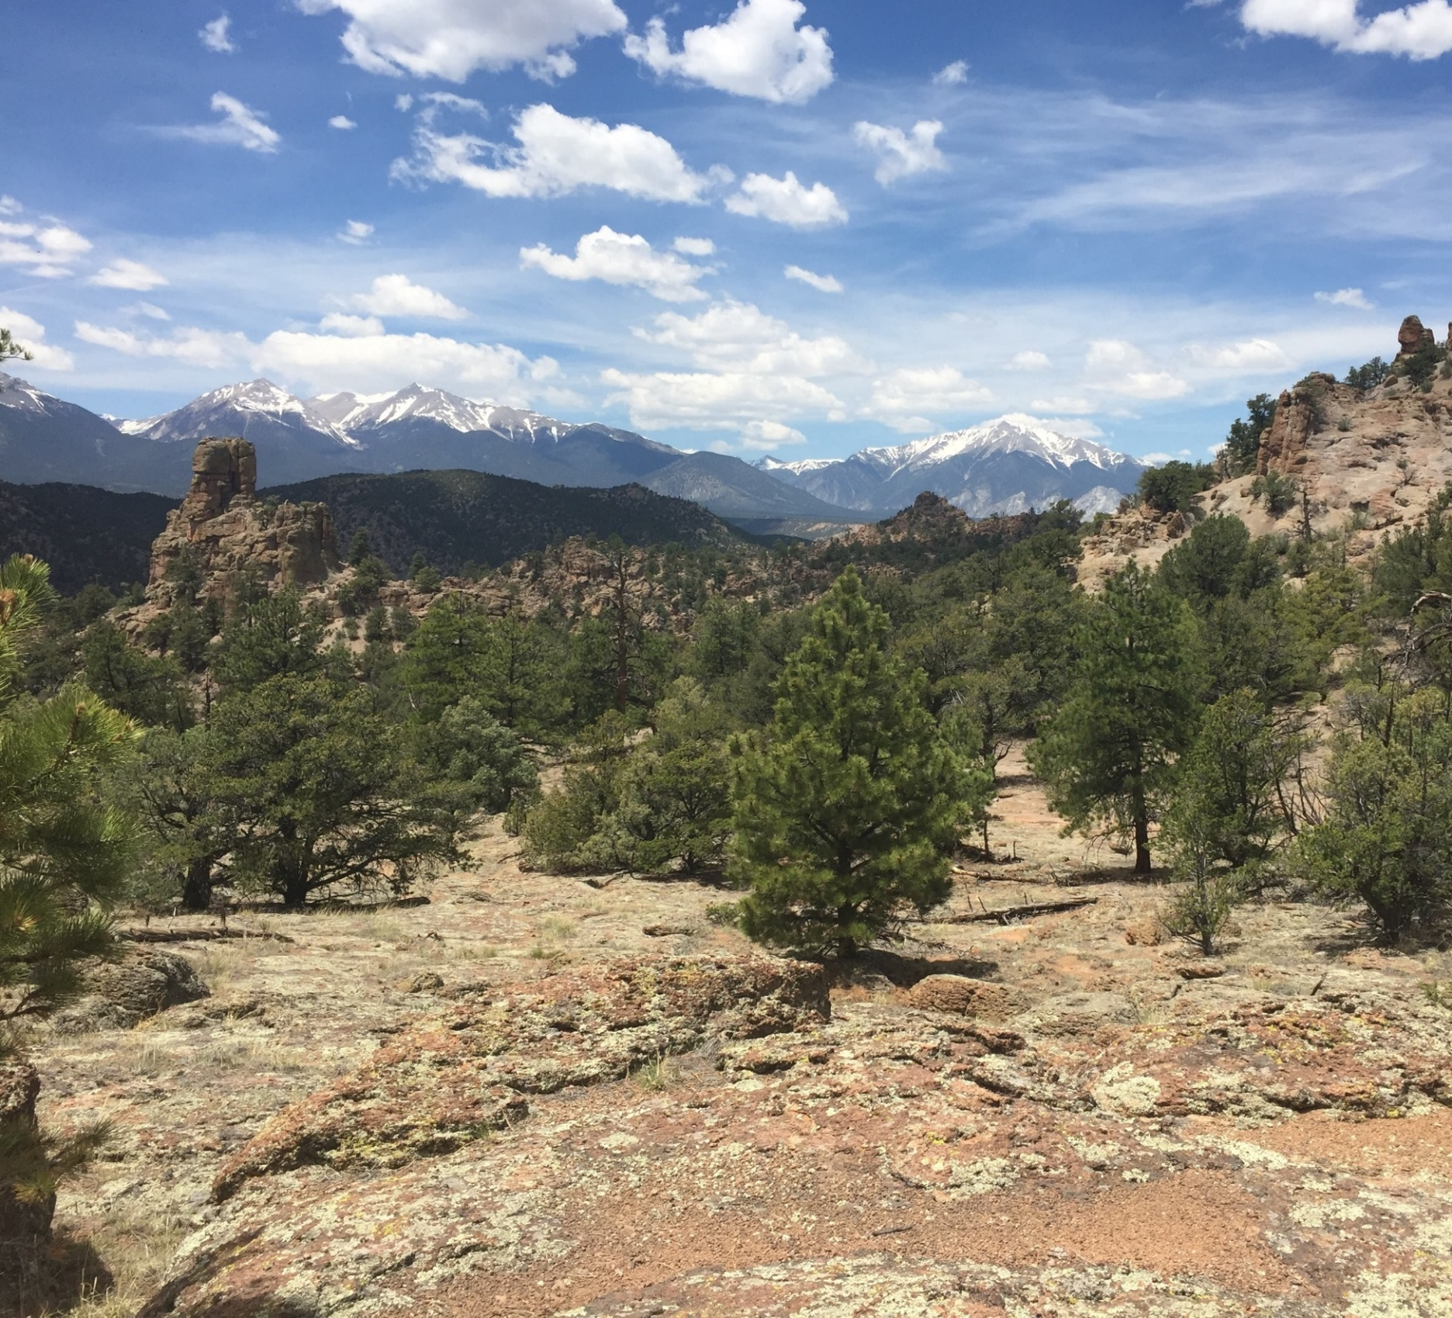

Table of Contents

Annual Manager’s Report—Fiscal Year 2017

Browns Canyon Profile 2

Planning and NEPA 6

Year’s Projects and Accomplishments 10

Science 14

Resources, Objects, Values, and Stressors 14

Summary of Performance Measures 17

Manager’s Letter 18

# Browns Canyon Profile

1

### Designating Authority

**Designating Authority:** Establishment of the Browns Canyon National Monument by the President of the United States of America, a Proclamation (Section 320301 of Title 54, United States Code)

**Date of Designation:** February 19, 2015

## Acreage

|  |  |
| --- | --- |
| **Total Acres in Unit** | 21,604 |
| **BLM Acres** | 9,793 |
| **Other Federal Acres** | 11,811 |
| **State Acres\*** | 0 |
| **Private Acres\*** | 0 |
|  | |

## Contact Information

|  |  |
| --- | --- |
| **Unit Manager** | Keith Berger (Acting) |
| **Phone** | (719) 269-8515 |
| **E-mail** | kberger@blm.gov |
| **Mailing Address** | 3026 East Main  Canon City, CO 81212 |
| **Field Office Name** | Royal Gorge Field Office |
| **District Office Name** | Rocky Mountain District |
| **State Office Name** | Colorado |

## Budget

|  |  |
| --- | --- |
| **Total Fiscal Year 2017 Budget** | $4,000 (2016 $125,000) |
| **Subactivity 1711** | $4,000 |
| **Other Subactivity Contributions**  **Subactivity 1610** | $637,000 Management Plan - EIS |
| **Other Funding (USFS PSICC Staff)** | $182,000 ($63,508: MP-EIS Contract) |

## Map of Browns Canyon National Monument

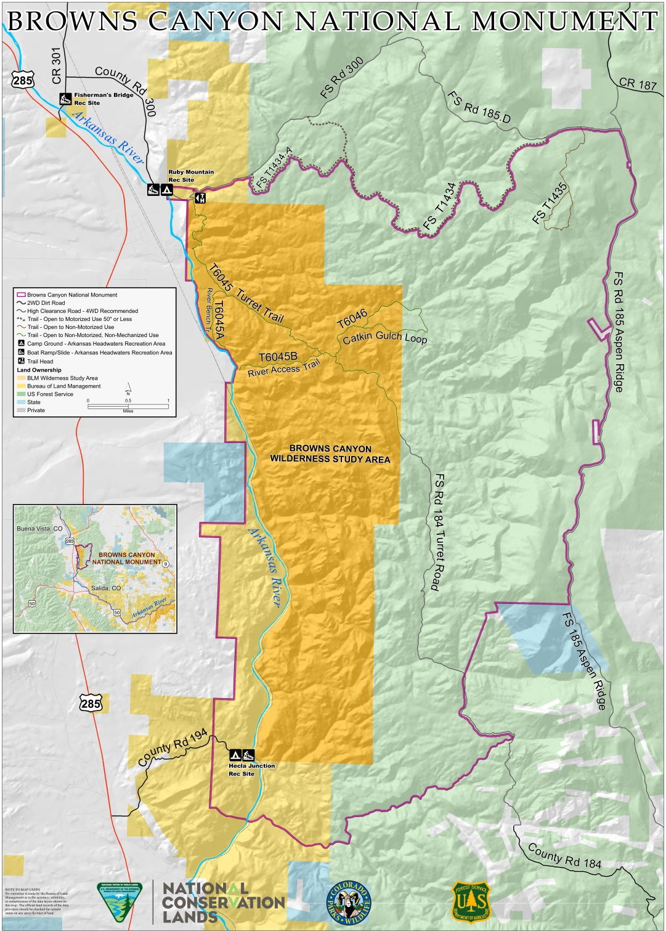

## Managing Partners

The Browns Canyon National Monument (BCNM), an area of 21,604 acres of scenic and diverse natural resources along the upper Arkansas River of Colorado, encompasses both BLM and U.S. Forest Service (USFS) lands. BCNM lands are managed jointly by the BLM Royal Gorge Field Office (RGFO) and the USFS Salida Ranger District (RD). The BCNM also includes the busiest stretch of river within the Arkansas Headwaters Recreation Area (AHRA), as administered under a cooperative management agreement between BLM, USFS, and Colorado Parks and Wildlife (CPW) since 1995. The BCNM managing partner authority for BCNM lands, resources, and objects of value is prescribed in Presidential Proclamation 9232 (B. Obama, Feb 19, 2015) as the Secretaries of the Departments of Interior and Agriculture, as delegated to BLM and USFS, respectively.

## Staffing

The BLM had no staff assigned permanently to manage and support the BCNM in FY17. Other BLM staff from the field and district offices conducted BCNM management and support workload dutieson an *as assigned* basis. Specifically, the BLM Royal Gorge Field Office (RGFO) Field Manager (GS-13) is the acting BLM Monument Manager. He is supported by the BCNM Management Plan-Environmental Impact Statement (MP-EIS) Project Manager-Planner (GS-12).

Within the RGFO, one outdoor recreation planner (GS-11), one park ranger (GS-9), and the RGFO Associate FM for renewable resources (GS-12; multiple subactivities) support recreation management, including facility development, volunteer coordination, and AHRA cooperative management coordination associated with BCNM. The same RGFO recreation staff support BCNM concurrent with other program duties in one of Colorado’s highest growth regions for OHV, mountain bike, rafting, hiking, and backcountry recreation, including hunting and fishing.

BCNM saw an estimated 350,000 visitors in 2017, including commercial rafting use along the river within AHRA. The RGFO recreation staff manages all recreation activities and programs on the approximately 500,000 acres outside of BCNM, so it is spread thin, particularly during busy summer weekends. The CPW staff provides law enforcement coverage along the river corridor, consistent with the BLM-USFS-CPW Cooperative Management Agreement (CMA), while one BLM law enforcement officer (LEO) covers all upland areas of BCNM and the rest of the RGFO.

In FY2017, staffing needs for recreation and visitor services in the BCNM grew and were driven by steep visitation increases at Ruby Mountain, Hecla Junction, and Railroad Gulch recreation sites, as well as along Turret and Aspen Ridge Roads. Increasing demand for recreation in BCNM reflects overall growth for commercial and private rafting, kayaking, hiking, angling, OHV use and other outdoor recreation activities throughout Colorado, Chaffee County, and public lands bordering the BCNM. With the declaration of the BCNM as a National Monument in 2015, visitation continued to grow, as evidenced by traffic counts at Ruby Mountain, and as public awareness of the “new” national monument increased due to active marketing by the state rafting industry, Chaffee County Chamber of Commerce, local hotels, restaurants, and others. Wide media exposure of the BCNM in 2017 also contributed to increasing daily summer season inquiries and map requests at AHRA and the Salida RD.

The RGFO also observes an increasing need for additional seasonal recreation operations at BCNM to protect the resources, objects, and values, for which BCNM was established. Specifically, the BLM sees a need for more regular field *ranger* presence at BCNM to work with volunteer groups and partner organizations, which are expected to grow in the winter and summer of 2018. Increased field presence would allow the BLM to address emerging management issues in BCNM such as trash, dog and human waste, coordinating youth and volunteer crews, trail maintenance, dispersed camping impacts, OHV trespassing, soil erosion, invasive species control, and access improvements.

To address these growing demands, the BLM RGFO identified the need for an additional seasonal recreation technician (GS -7/9) in FY18. This position will support increasing BCNM visitation, manage use in the adjacent Fourmile Travel Management Area, provide a regular presence at Ruby Mountain, Hecla Junction, and Aspen Ridge recreation sites, engage with the public, conduct environmental education activities, coordinate volunteer groups, and support citizen science initiatives.

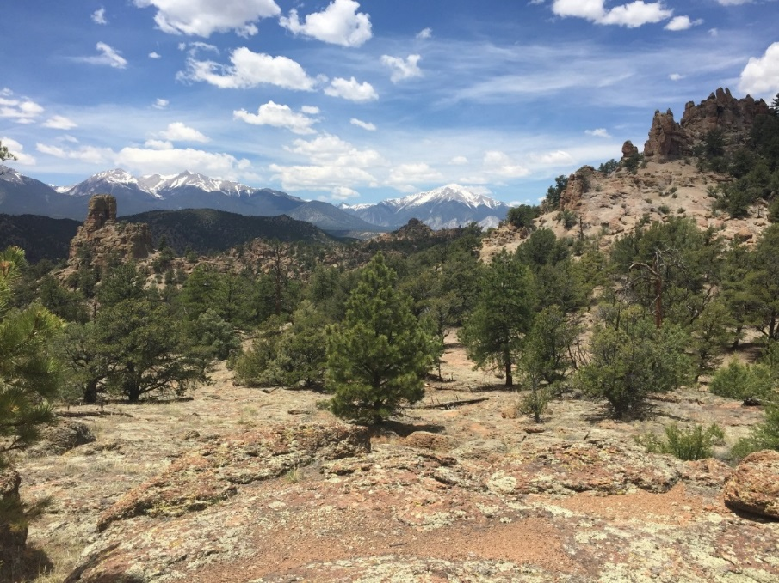

Figure 1.1. Browns Canyon Wilderness Study Area, ACEC, and National Monument. Photo: J. Vieira, BLM, 2017.

# Planning and NEPA

2

## Status of the Resource Management Plan

The BCNM Resource Management Plan (RMP), a joint BLM-USFS decision document per Presidential Proclamation 9232, is in the pre-NEPA phase, which includes development of the BLM Analysis of Management Situation (AMS) and USFS Assessment. BLM is the lead agency for NEPA and contracting. In FY 2017, the BLM completed solicitation, competitive contracting, award issuance, and contract initiation. Also in 2017, the BLM, USFS, and CPW formed an interdisciplinary team (IDT) and began compiling information to support the RMP, which included reports, data, and inventory updates. The IDT also conducted other AMS-Assessment activities, including an analysis of current and historic uses, to help characterize the resources, objects, and values for which BCNM was established.

BLM’s central focus of BCNM management planning in FY2017 was engagement with USFS, state and local government, tribes, local communities, the Friends of Browns Canyon National Monument, other interested public organizations, and the general public. The BLM actively and regularly coordinates with the BCNM federal co-lead (USFS), state cooperator (CPW) and local government (Chaffee County) in development of the land use plan. The BLM intends to draft the BCNM AMS-Assessment report with the assistance of the contractor in the first quarter of FY2018 and release the report for public review to coincide with NEPA scoping in the second quarter.

a b c

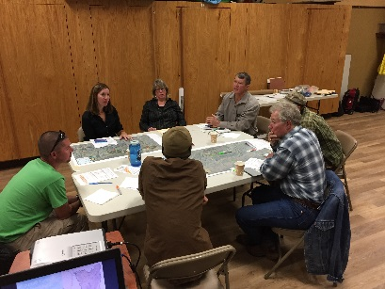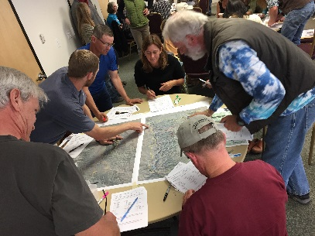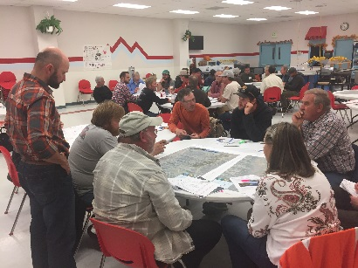

c d e

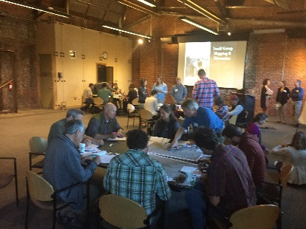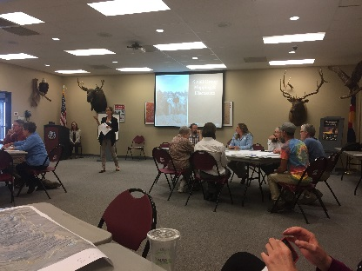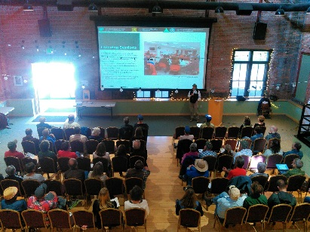

Figure 2.1. Browns Canyon National Monument management plan public listening sessions, participatory human ecology mapping exercises in Leadville (a), Salida (b), Buena Vista (c), Denver (c), and Colorado Springs (d) Colorado, in October–November 2016. A follow-up public validation meeting of monument mapping and information gathered in person and online, was held in Salida, CO, in May 2017 (e). Photos: BLM.

In FY2017, BLM and USFS jointly completed a pilot public engagement process employing individual stakeholder listening sessions, open public meetings, and on-line geographic data collection exercises (Figure 2.1). BLM engaged local elected officials, state agencies, commercial and private rafters, ranchers, hikers, hunters, anglers, military veterans, wilderness advocates, OHV enthusiasts, and others in the process. This effort, and the data gathered, help to inform the agencies’ management planning process regarding the goals, vision and values of state and local government, and had to inform the public concerning the long-term stewardship of BCNM resources, objects and values.

Social scientists and geographers from the USFS Pacific Northwest Research Station and the University of Colorado–Colorado Springs (UCCS) used a systematic approach to gathering spatially referenced data concerning monument recreation and grazing use. Specifically, the public mapped resource interactions, experiential outcomes, and values in six public meetings in Salida, Buena Vista, Leadville, Canon City, Denver, and Colorado Springs during the fall of 2016. To accomplish this, the research team utilized an innovative online mapping application hosted by UCCS and Tierra Plan. BLM presented a draft report titled *Social Landscape of the Browns Canyon National Monument* for public review at a follow-up public meeting in Salida, CO, May, 2017 (Figure 2.2). The final report is available on the BCNM RMP ePlanning site for public download (BLM approved short url: <https://go.usa.gov/xn2eC>).

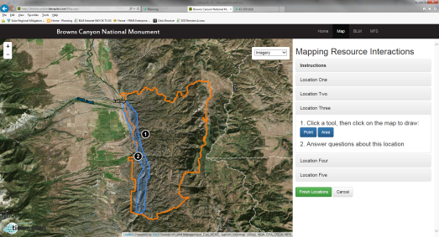Figure 2.2. Browns Canyon National Monument Human Ecology Mapping online data collection tool employed by University of Colorado–Colorado Springs and Tierra Plan for open public listening sessions from October 2016 to January 2017. Image: Tierra Plan.

The BCNM Plan will be a new stand-alone resource management plan for both BLM and USFS. The following land use plans and activity level plans currently manage the Monument:

* Royal Gorge Resource Area Resource Management Plan (RGRMP) 1996
* Arkansas River Recreation Management Plan (ARRMP) 2001
* Pike and San Isabel National Forests Cimarron and Comanche National Grasslands Land and Resource Management Plan (PSICC LRMP) 1984

The RGRMP and the ARRMP are currently undergoing revision. The PSICC will begin the revision process for the Forest Land Use Plan in 2020.  The BCNM plan will be analyzed through an Environmental Impact Statement (EIS) with separate Records of Decision (RODs) prepared by the BLM and the USFS. The BLM and USFS structured this joint plan to meet the needs of each agency, with the BLM acting as the lead agency in the planning process; CPW will participate as a cooperating agency.

## Status of Activity Plans

There are currently no associated BCNM-specific transportation or recreation plans outside of those associated with the RGRMP, ARRMP, and PSICC LRMP.  The ARRMP is an activity level plan that addresses river related recreation in AHRA, which includes the Browns Canyon Corridor. The BLM, the USFS and CPW are discussing how, prior to the release of the revised Eastern Colorado RMP (ECRMP), it may be necessary to implement interim management guidelines as necessary to address emergent issues that currently adversely affect or degrade the condition of protected resources, objects, and values in the BCNM.

## Status of the RMP Implementation Strategy

An RMP Implementation strategy is not applicable in the pre-NEPA phase. All current implementation actions for BCNM fall under existing plans, including the RGRMP, ARRMP, and PSICC LRMP. Within these plans, there are no specific management strategies for BCNM outside of actions identified in the previously designated ACEC, Wilderness Study Area, and USFS Roadless areas. The Presidential Proclamation establishing BCNM now withdraws BCNM from mineral entry with exceptions for valid and existing rights.

## Key National Environmental Policy Act Actions and/or Project Authorizations

BLM submitted a preparation plan to complete the Browns Canyon NM MP-EIS in November and May 2017, and drafted a Notice of Intent (NOI) to conduct public scoping in FY2018. BLM completed no new BCNM NEPA actions or project authorizations in 2017.

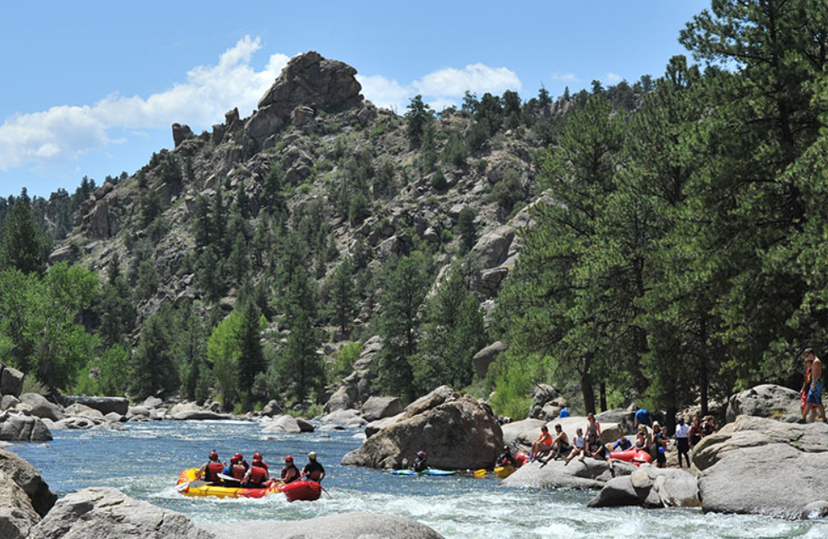

Figure 2.3. Whitewater rafters in the Browns Canyon National Monument. Photo: Luke Urbine, Friends of Browns Canyon.

# Year’s Projects and Accomplishments

3

## General Accomplishments

In FY2017, BCNM accomplishments included a social science assessment, recreation and visitor services improvements, volunteer resource stewardship events, joint federal-state-county traffic safety planning and project development, interdisciplinary team review of resources, objects, and values, including inventory updates, and initial tribal consultation to understand monument concerns. Specifically, the BLM consulted with the Southern Ute Indian Tribe and Rosebud Sioux tribe concerning a mining claim validity exam, and the tribe identified monument resources, objects, and values within the monument (Figure 3.1).

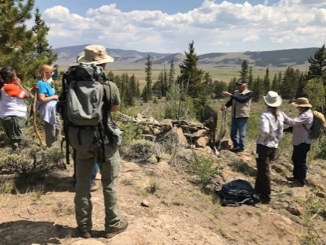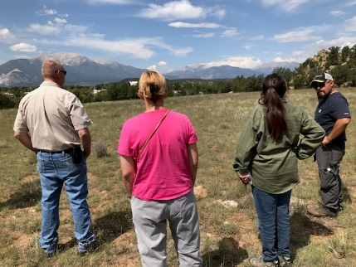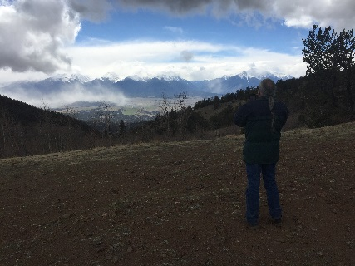

a. b. c.

Figure 3.1. BLM Rocky Mountain District and Royal Gorge Field Office tribal consultations in 2017 with Southern Ute Indian Tribe at Los Pinos Agency site (a); at Arkansas River Bench, Browns Canyon National Monument (b); and with Rosebud Sioux, Aspen Ridge Road, Browns Canyon National Monument (c).

At the Ruby Mountain recreation site, the BLM re-engineered and re-aligned access and parking, repaired flash flood-prone drainage and parking, and built a boulder-rock barrier. The new infrastructure improves recreation and visitor services, providing joint Fourmile OHV area parking and parking for BCNM anglers, hikers, and horseback riders, as well as a staging area. The BLM also installed a new vault toilet to address growing public sanitation issues. Additionally, BLM coordinated a federal-state-county cost-share partnership to reduce traffic collision risk on CR300, which is shared monument public access to Ruby Mountain Campground (CPW) and Ruby Mountain parking area (BLM) (Figure 3.2).

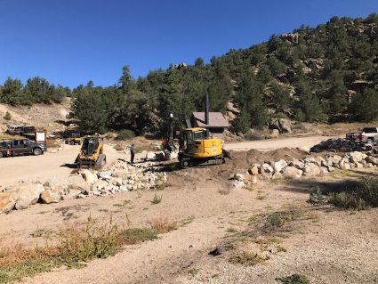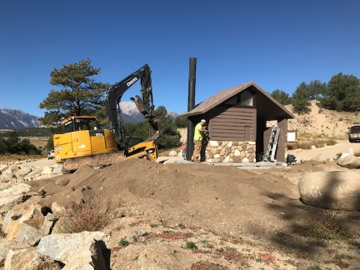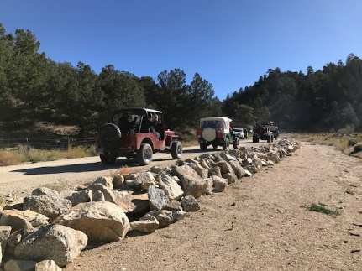

a. b. c.

Figure 3.2. BLM Ruby Mountain parking area infrastructure improvements engineered and installed to improve joint Browns Canyon National Monument and Fourmile OHV area recreation and visitor services, reduce flash-flood exposure and public safety risk, and improve public sanitation. Ruby-Fourmile parking improvements (a), latrine (b), and re-engineered ephemeral drainage and access (c).

In FY2017, the BLM hosted National Public Lands Day events in association with Friends of Browns Canyon. The group worked on noxious weed control, disturbed site restoration, and native plant seeding to reduce soil erosion and reduce duplicate trail spurs at the Ruby Mountain trailhead. The BLM hosted multiple additional volunteer events with Friends of Browns Canyon, Volunteers for Outdoor Colorado, Southwest Conservation Corps, and Back Country Horsemen to restore re-routed trails, install monument signage and a backcountry horse hitching post, and conduct other trail improvements (Figure 3.3).

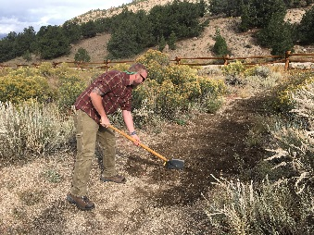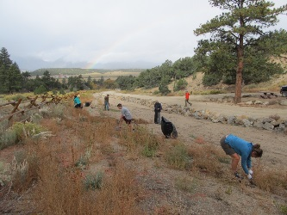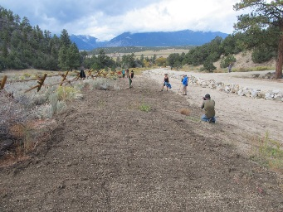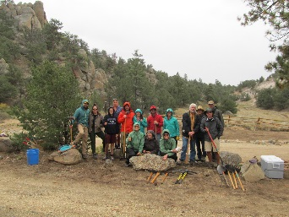

a. b. c. d.

Figure 3.3. Public Lands Day at Ruby Mountain, September 23, 2017. Friends of Browns Canyon volunteer applies seedbed on retired trail (a); noxious weeding (b;, post-weeding results (c); and volunteer work group (d). Photos: C. Whisenhunt (BLM); A. Stewart (VOC).

## Current Areas of Focus

Major focal issues for BCNM in FY2017 included responding to FY2016 partner requests for improved public access, infrastructure and facilities, and improving outreach and interpretation efforts, including sign installation. Completing volunteer resource stewardship and trail improvement projects and the development of monument media and interpretive products were a focus of the BLM Rocky Mountain District and the BLM Colorado State Office in FY2017 (Figure 3.4). During winter, spring, and summer 2017, BLM and USFS interdisciplinary team staff and field crews compiled the best available scientific information, gathered monument recreation and grazing data, completed field inventory of terrestrial wildlife, avian, and riparian habitat, documented cultural resources, and completed advanced vegetation mapping focused on the resources, objects, and values identified for protection in Proclamation 9232 (Figure 3.5).

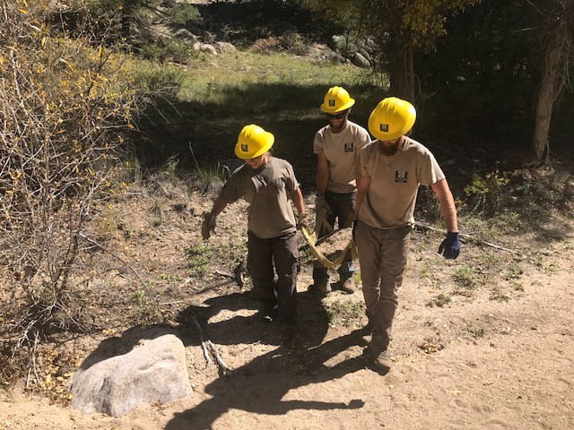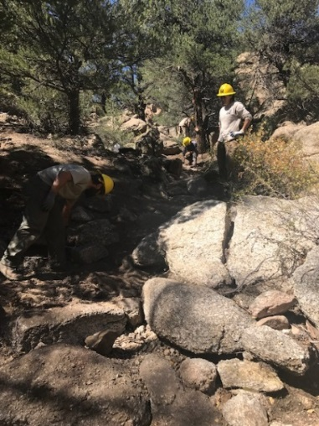

a. b.

Figure 3.4. Volunteers for Outdoor Colorado – AmeriCorps – Southwest Conservation Corps Youth Crew employing wilderness skills (a) to repair steep trail and drainage (b) at BCNM Little Cottonwood Creek (September 2017).

The BLM and USFS interdisciplinary team completed pre-scoping for BCNM resource and object of value reports in FY2017, including characterizing monument riparian resources, grazing, wildlife, fire ecology, and sensitive plants. Three agreements and memoranda of understanding between agencies and partners (USFS-BLM, USFS/BLM- CPW, USFS/BLM- Chaffee County) were approved or in review in FY2017.

## Education, Outreach, and Interpretation

The BLM conducted BCNM education and outreach efforts associated with management planning in FY2017, including the mapping of values and sense of place identified during pre-scoping (Figure 2.1). The BLM also completed environmental education programs for the second consecutive year for local fourth graders. This included field trips and nature education programs for Buena Vista and Salida schools, led by the BLM and the Greater Arkansas River Nature Association.

## Partnerships

Partnerships are central to the success of the BLM and USFS in connecting with communities, leveraging resources and funding, and monitoring and inventorying the BCNM’s resources. Primary partnerships include:

* CPW: River recreation management in AHRA on the Arkansas River through BCNM
* Chaffee County: Access and visitor use
* Salida and Buena Vista Visitors Bureaus: Visitor use and education
* Friends of Browns Canyon: Public Lands Day and BCNM listening session promotion.
* Veterans Expeditions: Monitoring and Bio Blitz support

In September 2017, as part of the BLM-USFS BCNM partnership, BLM helped to coordinate and facilitate the USFS International Program Central Asia Protected Area Study Tour at the BCNM. The BLM, USFS, and CPW hosted counterparts from 18 protected areas in Kazakhstan, Kyrgyzstan, Tajikistan, Uzbekistan, Turkmenistan, and Ukraine. Discussions with the group included topics such as BCNM establishment as a new protected area, interagency and community engagement in protected area planning, and land use planning for a newly established monument. Partners from Friends of Browns Canyon, Veterans Expeditions, Trout Unlimited, Wilderness Aware Rafting, and Colorado Parks and Wildlife contributed and participated in the two-day event (Figure 3.6).

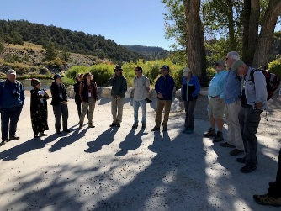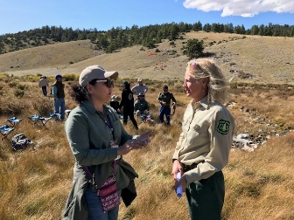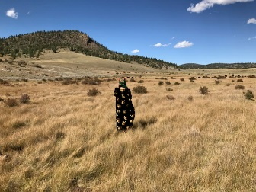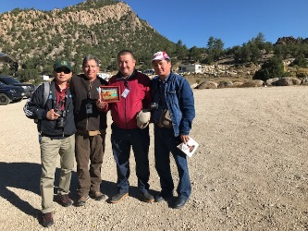

a. b. c. d.

Figure 3.6. BLM-USFS International Program Central Asia Protected Area Study Tour at Browns Canyon National Monument (September 2017). Community partners from CPW, Friends of Browns Canyon, Veterans Expeditions, Trout Unlimited, and Wilderness Aware Rafting participate in community engagement panel with Central Asia protected area managers (a); biologists from Turkmenistan and Colorado discuss monument wildlife resources (b); Tajikistan Protected Area manager in BCNM (c); Protected area managers from Kyrgyzstan pose with BCNM staff (d).

## Volunteers

BCNM does not currently have a formal, established volunteer program, but has incorporated volunteer projects into the annual program of work. BLM collaborates with USFS and co-funds a Volunteers for Outdoor Colorado coordinator who supports BCNM activities and events (Figures 3.3 and 3.4). Several individuals and organizations have expressed interest in volunteering at BCNM, including:

* Salida and Buena Vista Visitors Bureaus: Visitor use and education
* Friends of Browns Canyon: National Public Lands Day project
* Friends of Fourmile: travel management and visitor use monitoring
* Veterans Expeditions: Monitoring support, bioblitz
* Colorado Natural Heritage Program: bioblitz
* Denver Botanical Gardens: bioblitz
* Various local scientists and naturalists
* University of Colorado, Colorado Springs, Ecology students

## Land (or Interests in Land) Acquisitions

N/A

# Science

4

In FY2017, the BLM and USFS began studying and applying place-based social science and participatory mapping protocols to RMP development efforts. The study characterizes the current understanding of what constitutes the human ecology of special places within the monument, including resources, objects, and values. The study examined people-resource interactions, and identified user values and desired outcomes as a baseline of understanding for management plan development in FY2018–2020.

Study results portray public knowledge of specific places within the monument, participation level, and location of a variety of recreation activities, including rafting, hiking, jeep touring, and visiting historical sites. The study captures a strong local knowledge of resources, objects, and values, and characterizes recreation setting desired outcomes and amenity values as baseline and as perceived by the interested public in 2017.

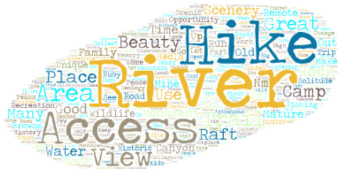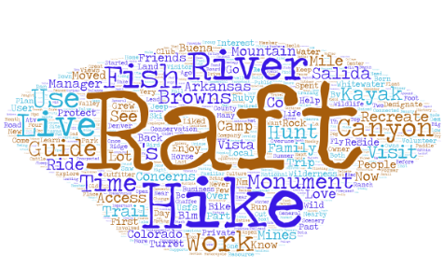

a. b

Figure 4.1. Human ecology mapping and social landscape of the Browns Canyon National Monument word art diagram of responses to the questions, *“What makes the Browns Canyon area special?”* (Size = measured overlap) (a); and *“What are your connections to the Browns Canyon area?”*(b). These were collected through six open listening sessions and an online tool in Colorado (October 2016–January 2017). Map package data collection by USFS Pacific Northwest research Station and University of Colorado, Colorado Springs.

# Resources, Objects, Values, and Stressors

5

During 2017, as a preliminary step in the monument management planning process, BLM and USFS independently compiled best available science and other high quality information for BCNM resources, objects, and values, as well as data on existing BCNM recreation and other uses. Specifically, the Federal agencies gathered information on the following ROVs for which the monument was created:

* Cultural and historical resources (including archaeological values)
* Ecological resources
* Riparian resources
* Geological resources
* Wildlife and birds
* Biodiversity
* Reptiles and amphibians
* Sensitive plant populations
* Scientific resources (including paleoecology, mineralogy, and climate change)
* Scenic resources

In April 2017, USFS-PSICC, in accordance with national forest planning directives, issued a public notice of a joint USFS/BLM BCNM ROV assessment. The consultation and coordination notice requested involvement of local, state, and federal agencies, tribes, and the public in the identification of studies, reports, literature, and data pertinent to understanding BCNM ROV conditions and trends. The notice both validated existing information sources, such as state wildlife studies and county economic reports, and helped USFS understand previously unknown BCNM ROV sources and references.

For some resources, objects, and values, BLM and USFS updated the inventory to describe conditions and trends of ROVs. For example, from June to August 2017, BLM and USFS riparian-wetland specialists and fishery biologists completed second-year inventories of 35 miles of stream corridor habitat (Figure 5.1). The BLM and PSICC soils and riparian specialists also inventoried soil types, located erosion prone areas, and assessed riparian conditions for each drainage within the monument.

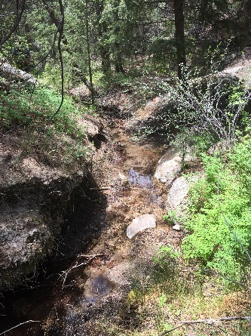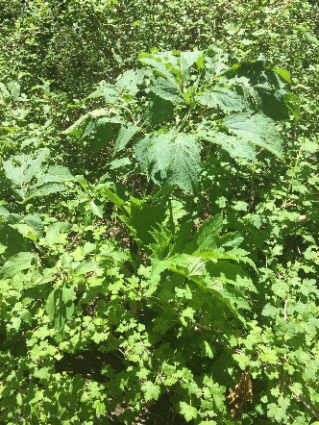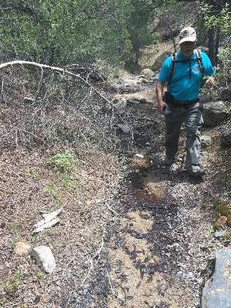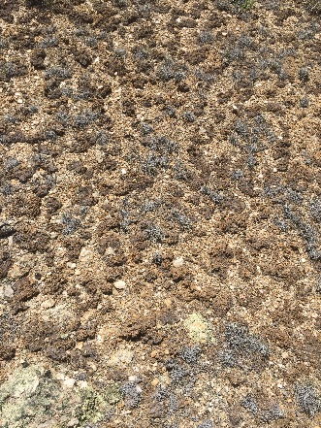

a. b. c. d.

Figure 5.1. BLM-USFS interdisciplinary Browns Canyon National Monument resource and object of value inventory and characterization update (2017); Sawmill Gulch riparian-wetland (a), Osha-*Ligusticum porteri* occurrence, a significant tribal medical plant, Little Cottonwood Gulch (b), riparian proper functioning condition survey (c); cryptogrammic soil occurrence (d).

Archaeological field technicians and cultural specialists surveyed 316 acres on USFS and BLM land in BCNM. Surveys took place from June-November 2016 and focused on locating and documenting Native American and historic resources previously recorded on BLM by archaeologists in the 1970s and 1980s. Technicians revisited and re-recorded 20 sites. This included 17 prehistoric sites, one multiple component prehistoric and historic site, and two historic mines. A previously undocumented historic site was also recorded. The sites date from 8,000 B.C to 1900 A.D. The field technicians located a variety of different Native American tools, most of which are associated with prehistoric hunting and food processing. Of note, a buried charcoal stain was found exposed in a cut bank and could be the remnants of a prehistoric house or large cooking feature

The BLM, USFS, and CPW completed the first bio-blitz initiative in the summer of 2016, in which they obtained initial inventory and monitoring information in order to help inform the planning process, including a special status species inventory. BLM and USFS completed follow-up surveys for peregrine falcon and tansyaster in 2017. In addition, BLM and USFS completed a second-year cultural resource inventory on key Arkansas River sites.

## Stressors Affecting Browns Canyon

BLM and USFS are evaluating baseline ROV conditions, including ecological stressors and drivers affecting the resources, objects, and values trends concurrent as part of a planning assessment scheduled for completion in 2018. BLM and USFS will describe ecological stressors and drivers in more detail in a report for agency and public review. Initial ecological stressors and drivers identified in 2017 that are influencing ROVs include:

* River recreation (riparian)
* Expanding backcountry recreation (avian nesting)
* Abandoned railroad (hydrology)
* Railroad hazmat sites (soils and water)
* OHV trespass (soils)
* Historic logging and past grazing pressure (vegetation, soils
* Insect pests and disease (forest health)
* Drought, flood, temperature, and precipitation trends (vegetation, forest health)

# Summary of Performance Measures

6

Status (condition) and trend of Browns Canyon National Monument resources, objects and values (ROVs), as known in FY2017 are qualified here. BLM-USFS will complete a more thorough assessment of ROV condition and trend, including identification of best available science, baseline data gaps, and need for management change in FY2018.

|  |  |  |
| --- | --- | --- |
| **Resources, Objects, and Values Status Summary Table** | | |
| **Resource, Object, or Value** | **Status** | **Trend** |
| Cultural/Historical Resources | Good | Stable |
| Ecological resources | Good | Stable |
| Riparian resources | Good | Stable; select riparian sites trending downward in Arkansas River corridor and Bassam Park |
| Geological resources | Good | Stable |
| Wildlife and birds | Good | Stable |
| Biodiversity | Good | Stable |
| Reptiles and amphibians | Good | Stable |
| Sensitive plant populations | Good | Stable |
| Scientific resources (including paleoecology, mineralogy, and climate change) | Good | Stable |
| Scenic resources | Good | Stable |

# Manager’s Letter

7

In 2018, we anticipate working closely with the USFS Pike and San Isabel National Forests and Comanche and Cimarron Grasslands (PSICC), Colorado Parks and Wildlife (CPW), Chaffee County, tribal governments, and the public while we develop the management plan for the Browns Canyon National Monument. We also look forward to building on the meaningful public input and deep local knowledge that we documented with rafters, hikers, grazing permittees, and others through the participatory mapping sessions that we hosted during 2017.

Our BLM and PSICC team takes seriously our federal responsibility under the law to best plan for and protect the resources, objects, and values of Browns Canyon National Monument. Through 2018, we aim to insure experiences of recreational value to the thousands of annual visitors who visit Browns Canyon National Monument and support our heritage ranching community that relies on its foraging resource.

Leveraging the best available scientific information, during FY2018, our interdisciplinary team anticipates documenting our understanding of the social, economic, and ecological conditions and trends that affect monument resource, objects, and values. These include it’s terrestrial and avian habitat, archeology, river corridor, rugged canyons, riparian galleries, woodlands, and high-elevation forest. We intend to share our understanding in a planning assessment report with the tribes as a part of government-to-government consultation, and with the public as a part of NEPA public scoping during 2018. Later in the year, our joint BLM and USFS field team will build on the issues and concerns identified during scoping - and some that were shared in 2017 - to build on our assessment, and flesh out monument management goals, objectives, desired future conditions, and the alternative ways of achieving them.

Finally, we look forward to continuing to work closely with the tribes, Chaffee County Government, the Rocky Mountain Resource Advisory Council, the Grazing Advisory board, grazing permittees, the Friends of Browns Canyon, Volunteers for Outdoor Colorado, and others in the local communities, in the spirit of BLM’s “Connecting with Communities.”

We foresee a very busy year ahead in 2018, focused on planning the management of the Browns Canyon National Monument and continuing the visitor services in dedicated partnership with PSICC and CPW.

**Keith Berger**

**Acting Browns Canyon National Monument Manager**



The mention of company names, trade names, or commercial products does not constitute endorsement or recommendation for use by the federal government.

**Browns Canyon**

**National Monument**

Rocky Mountain District

Royal Gorge Field Office

Phone: 719-269-8500

3028 East Main

Canon City, CO, 81212

**11/15/2017**