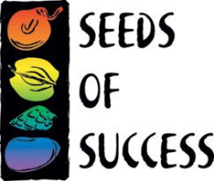
SEEDS OF SUCCESS
TRANSMITTAL NOTICE
(For Federal Collectors)

Date

U.S. National Herbarium
Smithsonian Institution (MRC-166)
10th and Constitution Ave., NW
Washington, DC 20560

Dear Smithsonian National Herbarium,

Our office, [name of office], is transferring these materials to the Smithsonian for inclusion in the Seeds of Success National Collection.

Thank you and we appreciate your partnership with Seeds of Success.

Sincerely,

[Your Name, Contact Information]
[Address of Field Office]

