Celebrating a Decade of Success – Restoring Habitat for the Endangered Least Bell’s Vireo
The Amargosa River flows through one of the hottest and driest regions in the western United States. As one of only two large rivers in the Mojave Desert, the river supports a wide array of valuable resources and represents a unique addition to the National Wild and Scenic River System. Summer temperatures often rise above 120 degrees and rain fall seldom reaches this part of the river. The approximately 180-mile Amargosa River begins its southerly, largely underground flow near Beatty, Nevada. A short segment near Oasis Valley in Nevada supports shallow, perennial water flow, but the river then generally flows in a sub-surface fashion as it bisects the remainder of the Amargosa Desert in Nevada. Near the towns of Shoshone and Tecopa, California, the river again peaks above the parched desert surface. In this area water flows above ground year around supplied by an extensive underground aquifer system and provides an island of lush green in the vast desert sea. This isolated oasis provides a home for many sensitive and endemic plant and animal species. In recognition of its importance, this stretch of the Amargosa River was designated by the Bureau of Land Management as an Area of Critical Environmental Concern in 2002 and Congress designated 26 miles of it a Wild and Scenic River in 2009. The unique biological resources in this area have been identified as one of the rivers Outstanding and Remarkable Values, and in particular, this region is a haven for a variety of bird species. Over 250 bird species use this site for wintering, migratory stopover, and breeding habitat leading the Audubon Society to designate it as an Important Bird Area.

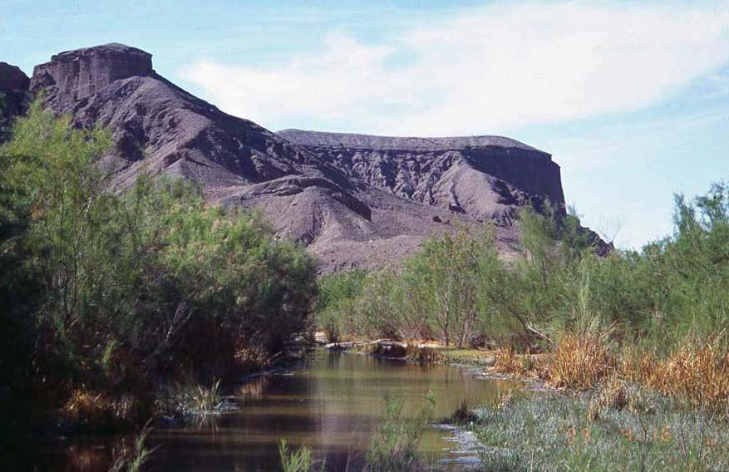

Figure 1: Amargosa Canyon showing habitat used by riparian bird species. (Photo by BLM Staff)
Avian breeding success associated with rivers in the southwestern United States has been adversely affected by the establishment of non-native species such as tamarisk (an invasive non-native tree) and the brown-headed cowbird (a bird nest parasite). The Amargosa River is no exception, large numbers of cowbirds frequent the area and dense stands of tamarisk abound. In order to enhance bird breeding habitat, the Barstow Field Office of the Bureau of Land Management, in conjunction with several partners including the United States Fish and Wildlife Service, California Department of Fish and Game, The Nature Conservancy, the Amargosa Conservancy, Point Blue (Point Reyes Bird Observatory), Natural Resources Conservation Service and local land owners established a Tamarisk Removal / Cowbird Management program in 2005.

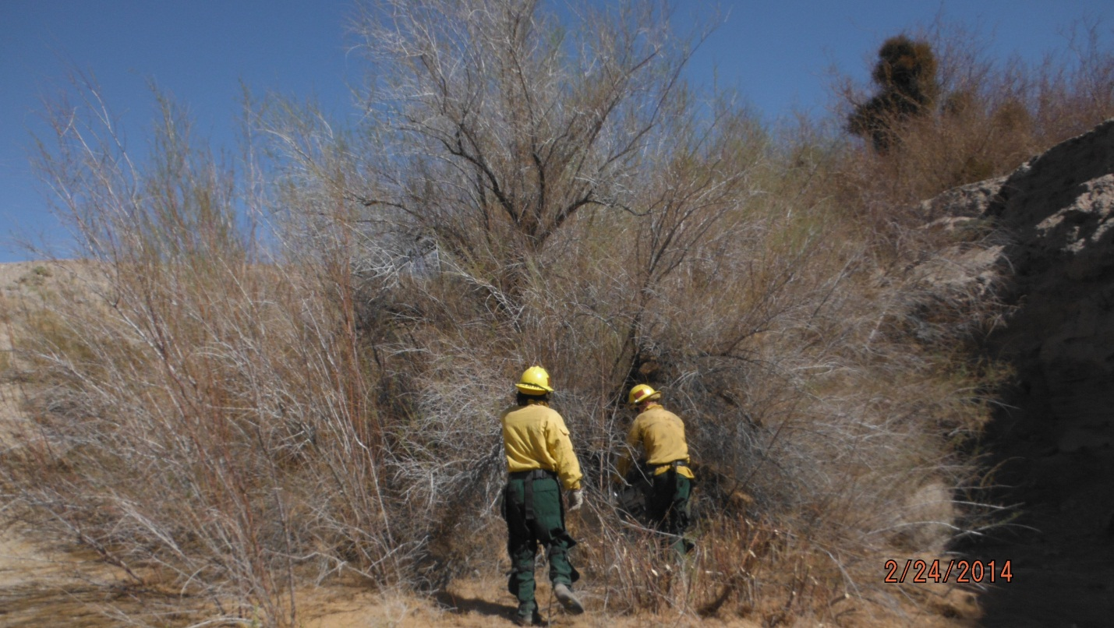

Figure 2. Fire crew removing invasive tamarisk. (Photo by, Miguel Mejia, BLM Staff)

Initial monitoring results of a 120 hectare study area have shown a significant reduction in the density of cowbirds and a significant increase in the productivity of several avian species in the study area, including the federally endangered Least Bell's Vireo, as a result of these management efforts. Prior to our management efforts, no Least Bell’s Vireo nested in the canyon, however by 2011 our efforts lead to successful nesting (90% success rate) and the fledging of 21 or 22 young within our study area. Now, based on analyses of our research partners, it is conservatively estimated that 250 Least Bell’s Vireo fledglings were produced in the greater Shoshone-Tecopa area during the 2014 breeding season. The BLM Barstow Field Office looks forward to continuing to foster the breeding opportunities for this endangered bird by cultivating our strong private/state/federal partnerships.

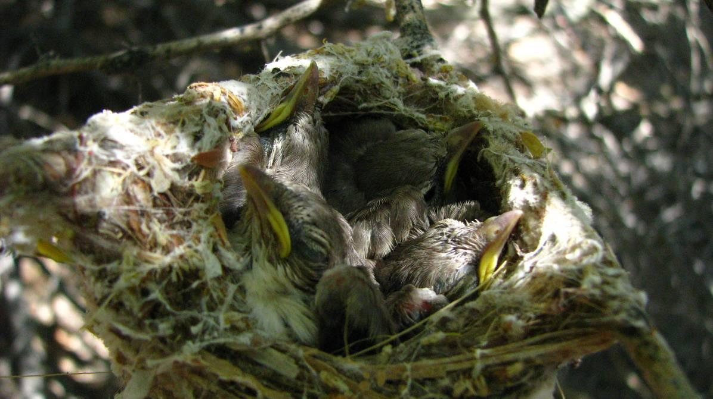

Figure 3: Nest with young Least Bell’s Vireo chicks. (Photo by, Chris McCreedy, Point Blue Staff)

To learn more about the Amargosa ACEC/WSR go to:
https://www.blm.gov/programs/national-conservation-lands/california/amargosa-wsr

-- Chris Otahal, Wildlife Biologist, BLM Barstow Field Office, California

