Attachment 6- AFMSS Bond Adequacy Review Instructions

Bond Adequacy Review (GLB.68)
AFMSS
To be updated after AFMSS2 module is developed and deployed

The Automated Fluid Minerals Support System (AFMSS) Bond Review screen basic information is below, outlined in screen shots and steps:

From the AFMSS Main Menu, click on Adjudication tab, and then click on select Bonds.

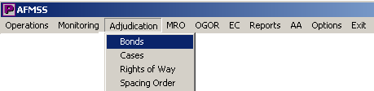

The Bond Status and Information (GLB.67) screen is launched.

From this screen, bond information can be added, edited, or deleted. A count of all Active bonds is also displayed in the lower right corner (orange arrow).

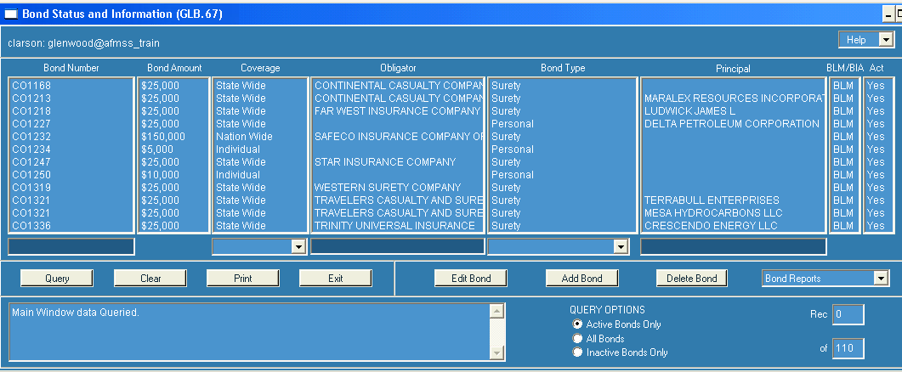

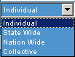

To find an existing bond, enter data into one or more of the Query By Example (QBE) fields (darker shaded fields), and click on “Query.”

Highlight the bond to be reviewed or updated, click on “Edit Bond.”
The Maintain BLM Bonds (GLB.68B) is launched.

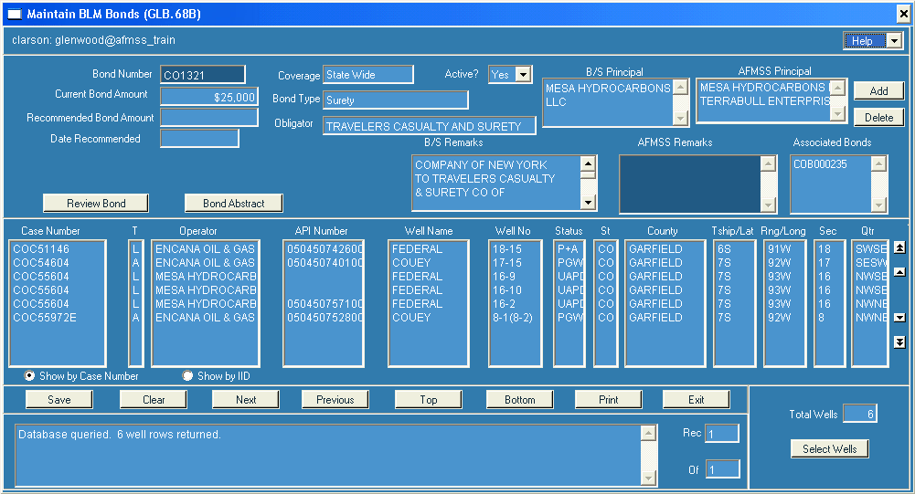

This screen contains information about the bond, completion of wells attached to the bond, the current bond amount, increases or decreases to that amount, and bond adequacy reviews performed. The “Bond Abstract” button links to the B&SS Bond Abstract. The “Review Bond” button allows for review entry and depicts review history of bond changes.
Additional fields: “Current Bond Amount” (which is from Bond and Surety and is the actual bond amount; Recommended Bond Amount); and “Date Recommended” (which is the date a bond increase/decrease is recommended to the State Office)
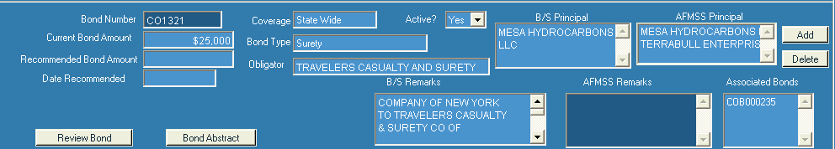

Entering Bond Review Information into AFMSS (BLM Bond Review History GLB.109B):
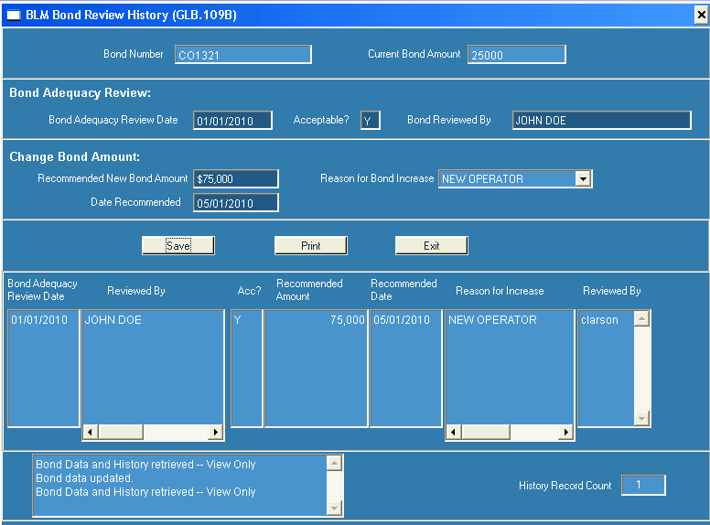
Enter the “Bond Adequacy Review Date”; “Acceptable” (Yes/No); and name of person performing the review. As needed, enter the “Recommended New Bond Amount” (in whole dollars), the date recommended (this is the date the FO sends the change request to the SO), and the “Reason for Bond Increase.”

Accessing Bond information in LR2000:
LR2000 Transactions Production Bond View
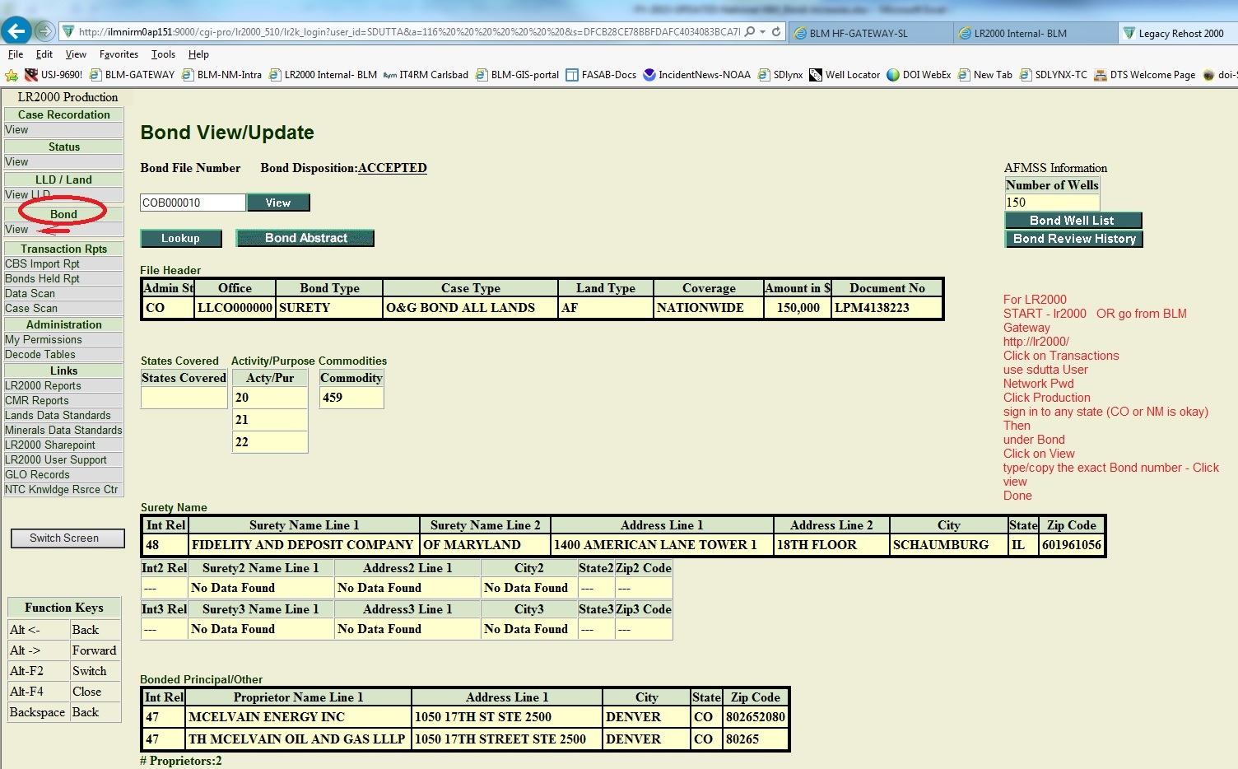

AFMSS bond reports: Bond Report (GLB.101) and Bonds Reviewed Report (GLB.102).
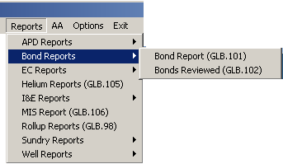
The reports can be accessed two ways; from the Adjudication Tab to the Bond Status and Information (GLB.67) screen or from the Report tab to the Bond Reports selection.
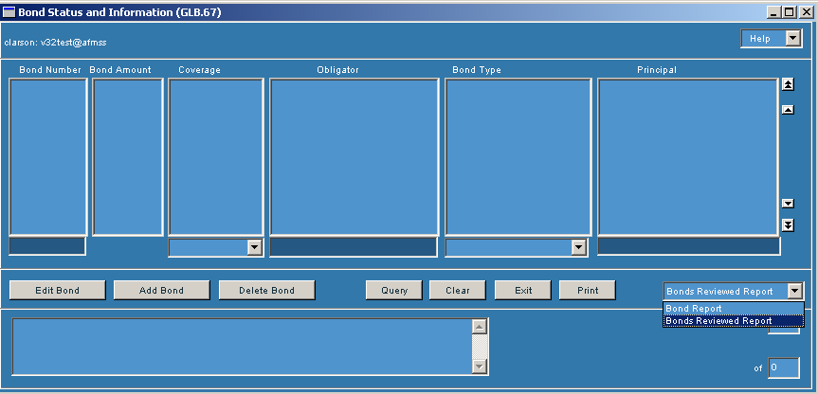

The Bond Report (GLB.101) will provide all information for each bond. If you want information for every bond, leave the criteria fields blank. However, if you want to limit the results of the report, there are several options available.

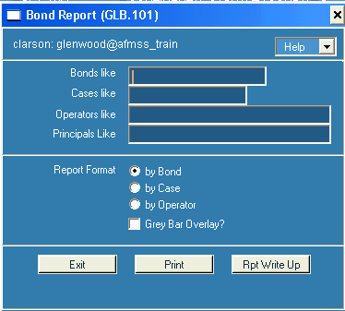

The Bond Reviewed (GLB.102) report retrieves the bond information for reviews conducted during a particular time period.
To print the remarks, click in the box next to “Print Remarks?”

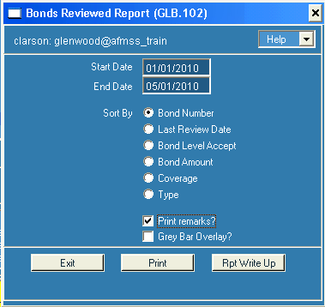

Both Reports can be printed to a CSV file and later opened in excel for ease of sorting.

