WHICH MODULE(S) SHOULD I USE (April 2022)
There are several kinds of data modules available for use. Data Entry Modules are used to facilitate data entry in the field. Data Analysis Modules are for validating and analyzing the field data and for data storage. The Statistical Analysis Module is for comparing the data from more than one Data Analysis Module to estimate condition and trend statistically.
Data Analysis Modules: There are three Data Analysis Modules:
Each module is applicable to a plant region (WMV – Western Mountains/Valleys and Coast, GP – Great Plains, and ARID – Arid west) as defined in the 2014 National Wetlands Plant List, http://plants.usda.gov/core/wetlandSearch
The following map depicts each of the three regions in the Western US: ARID WEST, WESTERN MOUNTAINS/VALLEYS and COAST, and GREAT PLAINS.
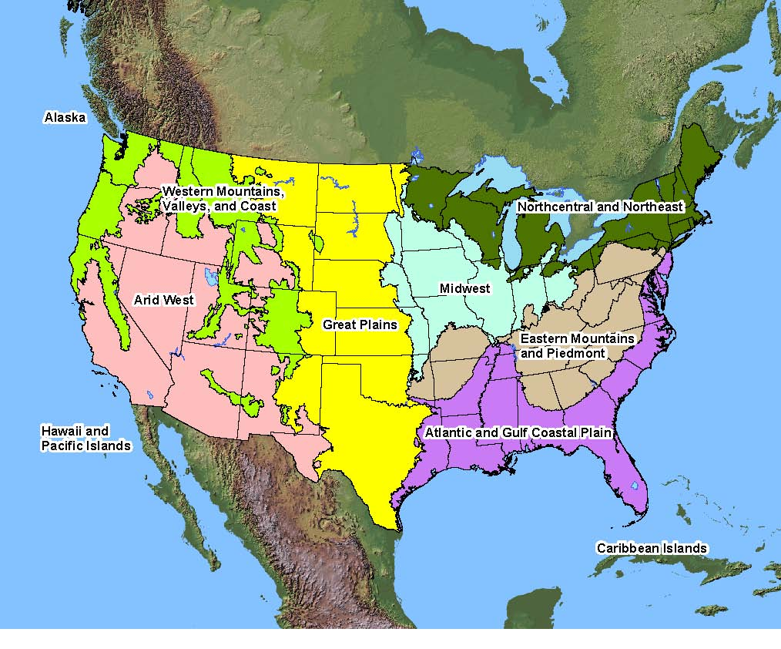

Data Analysis Modules are used to analyze and store the data. Although they can be used to enter data manually in the field, however as explained below, they are NOT as useful for field data collection as the Data Entry Modules. This file then becomes a record of the data collected and the analytical results. Files are stored and named according to users’ choice. A good convention is to name files by their DMA name, and date or year.
Data Entry Modules: There are four kinds of Data Entry Modules. The first two listed below (PDA) are used in field tablets that support the full version of EXCEL. The second two are used with field machines that do not support the full version of EXCEL and have not been updated in 2022.
Data Entry Modules: The full version (using full version of EXCEL) can be used for entering data using a device that supports “touch screen” input. It can also be used with other devices that do not support “touch screen” but use the full version of EXCEL. For “touch screen” tablets, the data entry cells will expand in size upon selection, and the amount of expansion can be controlled by the user. Many more drop-down lists are provided to minimize typing, allowing the user to select items in the list. Drop-down lists are specific to the plant lists and key species lists unique to the DMA. This makes manual data entry much more convenient than in the Data Analysis or other Data Entry modules. Also, this module contains a macro for automatically populating the species lists from prior field data collections events at the same DMA. The user migrates to a previous Data Analysis file and selects it. The module then migrates the plant and key species lists directly into the data entry module.
Data Entry Modules for Field PDAs: There are two files specifically designed for use with field devices that support Windows Mobile with EXCEL Mobile or others that do not support the full version of Windows and MS EXCEL. The Data Entry Module for PDA facilitates recording field data that is later transferred to the Data Analysis Module for analysis. The Data Entry Module Livestock Use is used specifically for entering short-term monitoring indicators (stubble height, bank alteration, and woody use), plus one long-term indicator - bank stability, that is often reflective of the effects of the short-term indicators.

