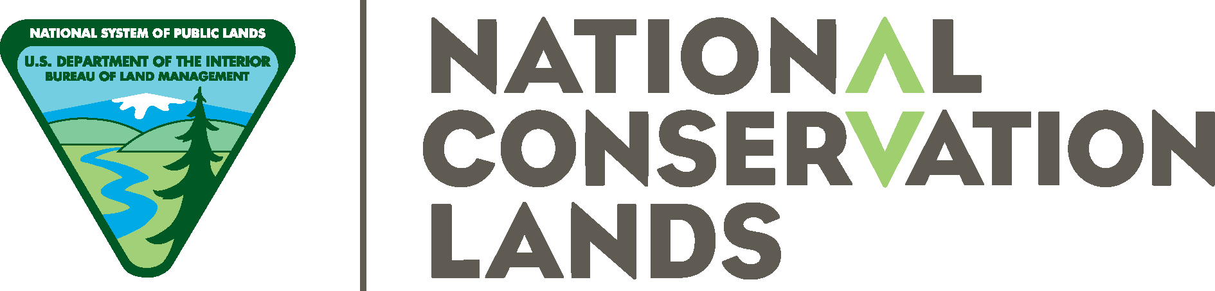

WELCOME TO RED ROCK CANYON NCA
ENJOY YOUR VISIT
Student’s Checklist
- Lunch
- Water- A minimum of one (1) liter or two (2) 16.9 Fl. Oz. bottles, NOT frozen, the water does not melt fast enough to drink.
- Coat/Jacket depending on weather (Red Rock can be 10°F cooler than the Las Vegas valley)
- Closed toed shoes suitable for hiking i.e. sneakers/boots
- Long pants (shorts are not recommended even in warm weather as we have plants that poke)
- Hat & Small day pack
- Name Tag (Especially for the Ranger-led field trip)
- Pencil & Note Paper



WELCOME TO RED ROCK CANYON NCA
ENJOY YOUR VISIT
Student’s Checklist
- Lunch
- Water- A minimum of one (1) liter or two (2) 16.9 Fl. Oz. bottles, NOT frozen, the water does not melt fast enough to drink.
- Coat/Jacket depending on weather (Red Rock can be 10°F cooler than the Las Vegas valley)
- Closed toed shoes suitable for hiking i.e. sneakers/boots
- Long pants (shorts are not recommended even in warm weather as we have plants that poke)
- Hat & Small day pack
- Name Tag (Especially for the Ranger-led field trip)
- Pencil & Note Paper

