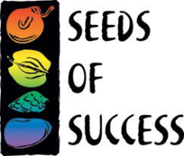
SEEDS OF SUCCESS
TRANSMITTAL NOTICE
(For Non-Federal Collectors)

[Date]

U.S. National Herbarium
Smithsonian Institution, MRC-166
10th and Constitution Ave., NW
Washington, D.C. 20560

Dear Smithsonian National Herbarium,

Our organization, [name of institution], is transferring these materials to the Smithsonian for inclusion in the Seeds of Success National Collection.

In this package are the following collections and their associated labels:
Species | SOS Collection Reference #
(Note to SOS collectors, please do not include copies of your data sheets)

Thank you and we appreciate your partnership with Seeds of Success.

Sincerely,

[Your Name, Contact Information]
[Address of Institution]

