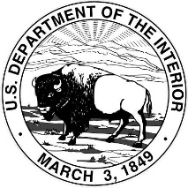
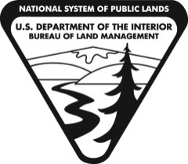
Enter Field Office Information
Adjust date here
Enter agency information receiving transfer animals animals

United States Department of the Interior

BUREAU OF LAND MANAGEMENT

[Insert your office name here]

[Insert office address here]

http://www.blm.gov

Click or tap to enter a date.

[Insert agency name & address]:
Enter # of animals being transferred

This letter serves as the official transfer of the [Insert # transferred] animals listed below from the Department of Interior, Bureau of Land Management, to the [Insert name of agency]. These animals are no longer protected by the Wild Free-Roaming Horses and Burros Act of 1971, as amended.
Enter agency receiving transfer animals
Complete animal(s) information fields

Freezemark Signalment Key Training Status Agency/Sector/Station
XXXXXX XXXXXXX XXXXXXX XXXXXXXXXX
Enter agency receiving transfer animals

This also serves as notice, per Consolidated Appropriations Act, 2017 (HUMANE TRANSFER OF EXCESS ANIMALS SEC. 116) that the [Insert name of agency] shall not destroy the horses or burros in a way that results in their destruction into commercial products; sell or otherwise transfer the horses or burros in a way that results in their destruction for processing into commercial products; or euthanize the horses or burros except upon the recommendation of a licensed veterinarian, in cases of severe injury, illness, or advanced age.

Thank you,

[Signature of Delegated Official at BLM OOJ]

Insert signature of Delegated Official at BLM OOJ

